Discover "Forward Motion," a Moving Exhibit by Kinetic Artist Pedro Sanchez de Movellán at the M.A.D.Gallery

The M.A.D.Gallery presents "Forward Motion," a collection of seven remarkable kinetic artworks by American artist Pedro Sanchez de Movellán. Harmonizing elegant forms with precise engineering, de Movellán creates engaging and everchanging sculptures that transform before the viewer's eyes.

"The sculpture is one of the best mediums for me to communicate a sense or feeling that cannot be put into words. The combination of balance, movement, colour, and shape are the portal for expression," explains de Movellán.

The "Forward Motion" exhibit turns our kinetic dreams into reality at the M.A.D.Gallery. Each piece is flawlessly crafted and uniquely brought to life – captivatingly turning, spinning, and moving freely with the assistance of a gentle breeze or light touch of the hand.

Creation process

Born into a family of artists, creativity runs in de Movellán's blood. "Ever since I was a boy, I loved making things, fixing things, and figuring out how things work. There was something about this triad that has stayed in me over the years," the artist shares. "One of the first explorations of balance involved finding a way to balance a stick on a rock and have it seesaw gently up and down. Something about that captivated me." This impression is carried through his work today, which centres around forward motion and draws on music, nature, and his love of all things mechanical.

The artist’s studio near his home in Massachusetts is a hybrid machine and woodworking shop brimming with tools, machines, computers, and large sanding tables. A master craftsman, de Movellán singlehandedly creates these dynamic works of kinetic art using machining tools as an extension of his hands to shape stainless steel and aerospace-grade aluminium.

Each piece necessitates a different timeline to mature, taking between a couple of days and six months from conception to completed work, with the construction process the longest and most crucial step. To achieve the desired performance, each component is meticulously shaped and weighted with brass counterweights enabling the shapes to oscillate uninhibitedly. "Most of the time, the challenge is making a sculpture that moves incredibly gracefully and light as a feather, yet [remains] strong and durable." Apart from a few pieces featuring pendulum and escapement mechanisms, the majority of de Movellán's artworks consist of simple rotating shafts on high-precision bearings.

“Forward Motion”

Even at rest, any of these seven mesmerizing works will transform a simple space into a vibrant one. Once powered by wind or hand, they build endless compositions as the shapes rotate and spin – as if dancing, these lyrical constructions waltz and sway elegantly to music only they can hear. Enhancing the visual experience, de Movellán often incorporates contrasting colours and materials.
Similar to the motion of a roller coaster, the five oblong shapes of the "Flying Dutchman" sweep and loop around, taking all in their presence for a wild ride, speeding up for fractions of moments before once again slowing down to gather momentum. This sculpture comprising black-anodized and nickel-plated aluminium and stainless steel stands 35 inches (88.9 cm) tall. In the same spirit but slightly smaller in size, "Dihedral Green" rhythmically spins two arms with teardrop-shaped extensions, their brushed surfaces cheerfully accented with a mint powder-coated edge.
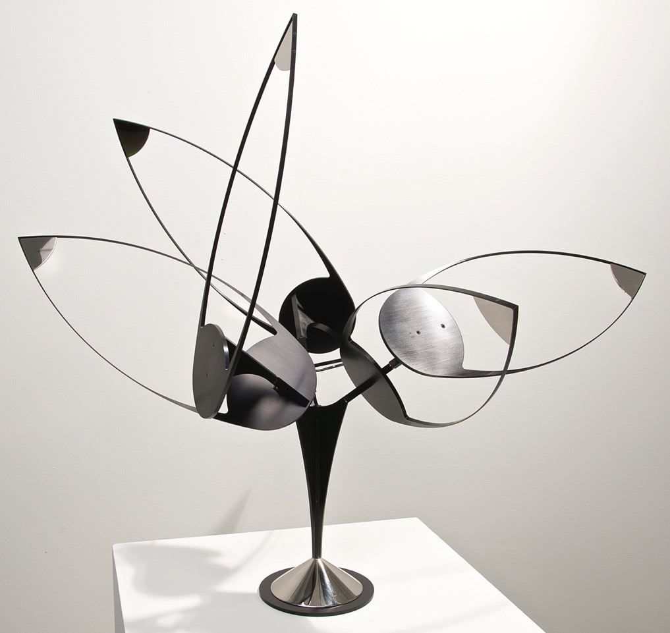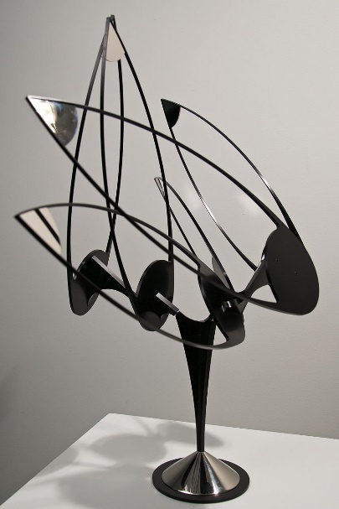

"Lunette" adds another dimension to the artist's work by strategically placing six arms with spinning teardrops on one axis, creating a dazzling show of seemingly choreographed movements. The kinetic sculpture standing 36 inches (91.4 cm) high features components made of brass, stainless steel, and brushed aluminium with a rich green powder-coated edge emphasizing the motion. Time seems to stand still when observing the endless geometric patterns unfolding in this work of art.
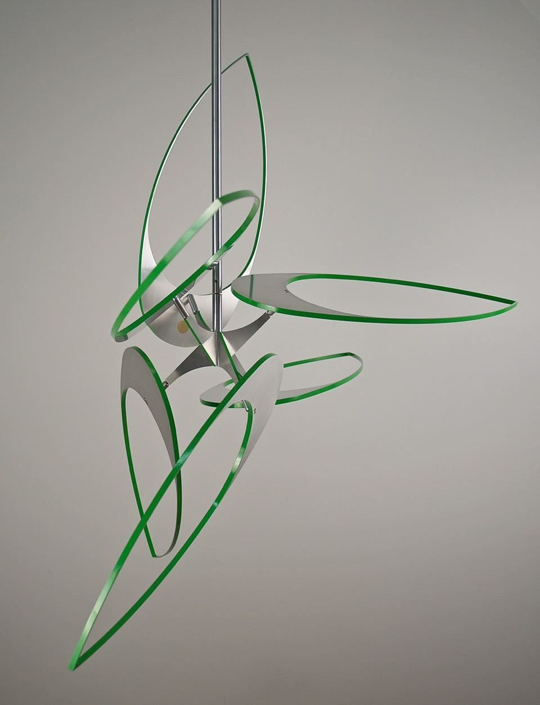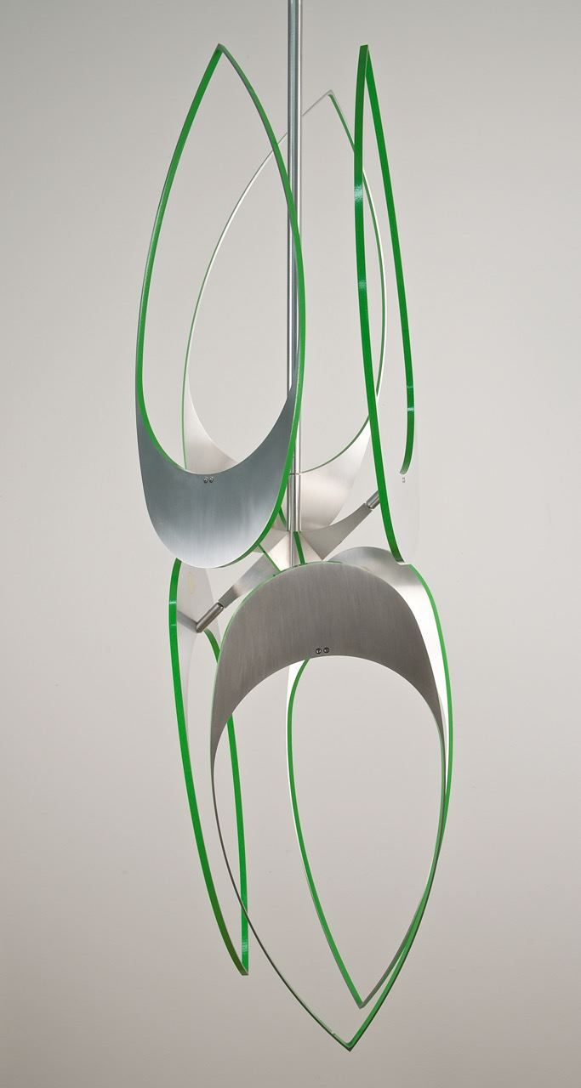

The ebb and flow of "Halcyon" is reminiscent of a kaleidoscope. Here, de Movellán strategically positions four golden arms ending in openworked circles and crescent shapes, vacillating in seamless motions creating a continuously evolving scene of shapes against a deep black backdrop. The fluid movement of this framed kinetic work is powered by electricity. "Halcyon" is made using powder-coated aluminium, acrylic paint on aluminium, powder-coated brass and stainless steel and measures 34 inches (86.4 cm) square and 5 1/4 inches (13.3 cm) deep.

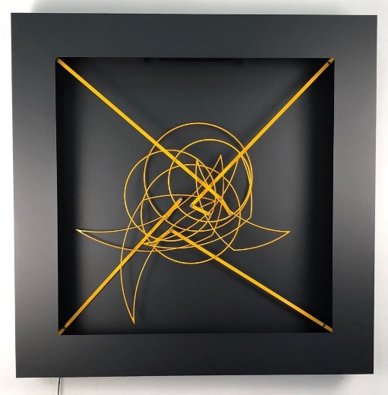

"Ephemeris" is an animated composition with an open structure that hangs on the wall. This round work is 16 inches (40.6 cm) in diameter and incorporates aluminium semicircles powder coated in black, swinging and turning as if on a collision course. Adding to the piece’s aesthetic, each airy shape is accented with a vibrant red lighting gel sheet, primarily used to change or filter the colour of light, moving to create endless patterns that slowly dissolve right before the eyes.

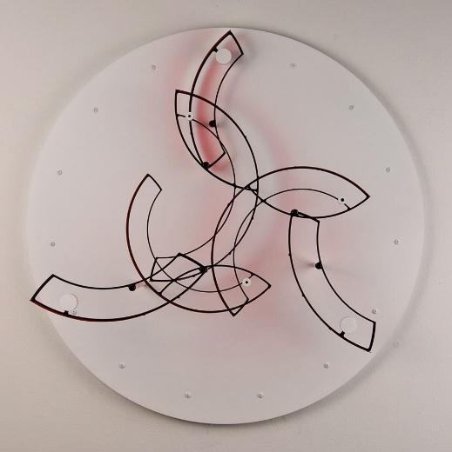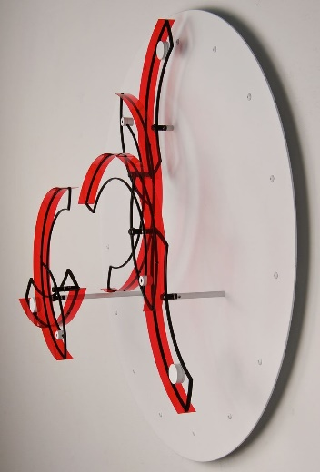

Through sound and motion, "Eclipse" captures the hypnotic power of kinetic art. Similar to a longcase clock, "Eclipse" is powered by a weighted pendulum and moves gracefully thanks to its time-portioning escapement; a clutch bearing allows only forward motion. Once in action, the arm swings in circular motions, almost emulating the hands of a clock. This impressive work makes the passage of time tangible, the ticking escapement and continuous motion tracking time without actually measuring it. At 30 inches (76 cm) wide by 34 inches (86 cm) tall and incorporating striking gold leaf accents, "Eclipse" would make an excellent addition to any wall space.

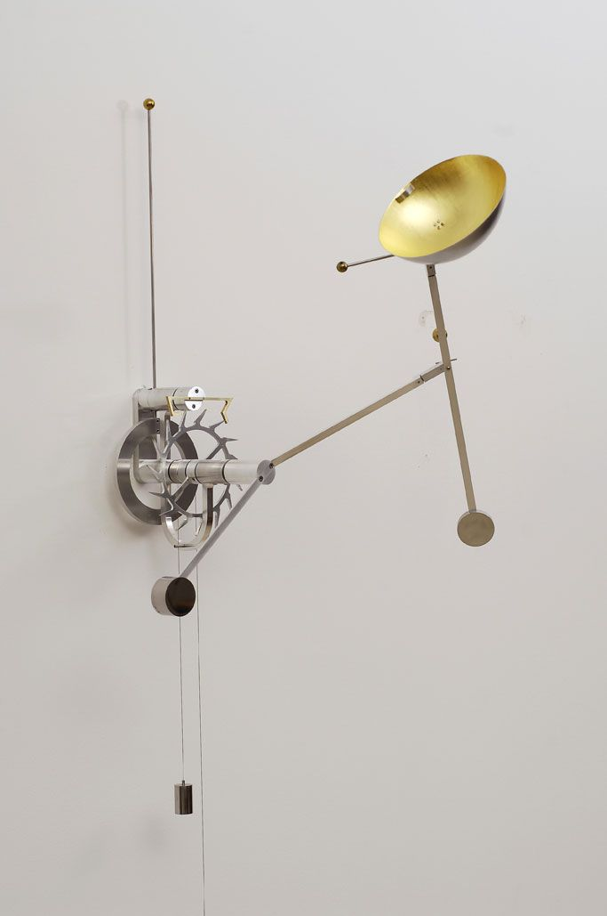

Each unique artpiece in the "Forward Motion" collection is signed by the artist.

About the artist

The son of an artist and an architect, de Movellán grew up in a world of creativity. Born in Providence, Rhode Island, USA, de Movellán moved with his family to Mexico at a young age. "As a child, my inclinations were making things and seeing how things worked. I always had a sense of what I felt was aesthetically pleasing as well," explains de Movellán. Eventually, he made his way back to the USA to attend the University of Amherst in Massachusetts to study fine art. "About halfway through my time there, something reawakened in me to begin creating sculptural forms. There was a sculpture near my campus by the artist George Rickey. A simple, stainless steel kinetic work that transfixed me. There was a simple elegance about the piece, yet the subtle motion opened up a whole new way to look at art for me," describes de Molleván.

Other pivotal moments in de Movellán's journey include an apprenticeship building wooden boats, where he gained carpentry skills including sanding curves and bending wood. Graduating with a bachelor's degree in fine arts, the artist met Maxwell Davidson, an influential art gallery owner in New York, who was instrumental in opening doors for de Movellán in the world of kinetic art.

Today, at 53 years old, de Movellán enjoys starting the day with an outdoor activity, whether it be paddle boarding, biking or trail running, and then retreating to his workshop, often feeling inspired to design by his encounter with nature. He is driven by a dream to create a massive outdoor installation to inspire others in making positive changes in the world.

