UAE serves as stunning backdrop for internationally acclaimed photographer Marc Ninghetto’s iconic “GrEndizer” exhibition at MB&F M.A.D.Gallery DUBAI

- ‘The Solitude of a Machine III’ Grendizer photography series is also the first collaboration for both Marc Ninghetto and UAE based landscape photographer, Rafi Kabbas

- Exhibition is on display starting from 10th December 2019 at the MB&F M.A.D.Gallery, The Dubai Mall

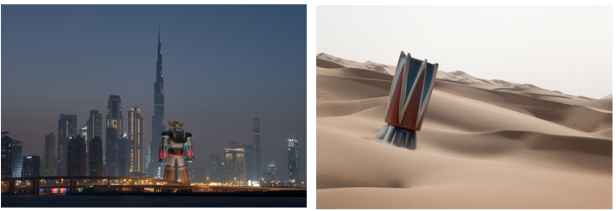
Dubai, UAE – 11th December 2019: The MB&F M.A.D.Gallery is proud to debut the 3rd edition of ‘The Solitude of a Machine’ photography series, which pays homage to iconic Japanese manga robot ‘Grendizer’, while being set against the backdrop of the majestic landscapes of the UAE. The series is the first ever collaboration of internationally acclaimed Swiss photographer, Marc Ninghetto, and UAE based landscape photographer, Rafi Kabbas, to create nine awe inspiring large-format prints, that juxtapose the larger than life Grendizer across memorable locations of the UAE, spanning both the urban skyline and the grand beauty of the desert.
Employing a technique called “digital sampling” which he has perfected over the years, Marc implements a meticulous process where he captures images of three-dimensional robot models and then expertly incorporates them within landscape and background photographs, ultimately enabling Grendizer to be a part of our ‘real’ world. Through the skillful use of shadow and light, the robot’s existence can range from dominate to subtle in the imagery, leaving a lasting and realistic impression.
“Grendizer featured very prominently in my childhood and to see him come to life and be portrayed in such a realistic way, against the backdrop of the UAE, is a very special feeling. We are always looking to push boundaries with the pieces that we showcase at the M.A.D.Gallery and I couldn’t be prouder to exhibit this body of work. It is also particularly noteworthy, that this is the first time that Marc Ninghetto has collaborated with another photographer, and we are particularly proud that it should be a resident of the UAE,” said Maximilian Büsser, M.A.D.Gallery founder and curator.
‘The Solitude of a Machine III’ Grendizer photography exhibition will be on display at the M.A.D.Gallery starting from 10th December 2019 at The Dubai Mall and includes:
Limited edition of 18 pieces and 2 artist proofs
Size: 120 x 84

Limited Edition of 8 pieces and 2 artist proofs
Size: 170 x 120

Limited edition of 3 pieces and 2 artist proofs
214 x 150

For further information please visit www.madgallery.ae

– END –

About the M.A.D.Gallery:

The MB&F M.A.D.Gallery is a captivating universe of kinetic art where Horological Machines and Mechanical Art Devices reign supreme. The first M.A.D.Gallery opened in 2011 in Geneva on Rue Verdaine, a stone’s throw from MB&F’s offices and atelier in the heart of the city’s old town. Then came Taipei in 2014, Dubai in 2016 and Hong Kong in 2018. Inside the galleries, not only will you find the complete range of MB&F Horological Machines and Legacy Machines, but you’ll also have the pleasure of discovering carefully-curated pieces – or, as we like to call them, Mechanical Art Devices – from around the world, each one making your heart beat that little bit faster.

About MB&F:

Based around one very simple and fundamental ideal: to assemble dedicated collectives of talented horological artisans, artists and professionals – all friends – to design and craft each year a radical and original horological masterpiece. By nurturing teams of talented individuals, harnessing their passion and creativity and crediting each individual's essential role, MB&F uses their synergy to become much greater than the sum of its parts. MB&F is above all a human adventure... a human adventure with just one goal: to create incredible horological machines. 14 years of hyper-creativity; 16 remarkable calibres forming the base of the critically acclaimed Horological Machines and Legacy Machines for which MB&F has become renowned.
About Ahmed Seddiqi & Sons:

Ahmed Seddiqi & Sons is the region’s leading retailer of luxury watches & jewellery. Established in 1950, the company has continuously developed and nurtured the needs of its clients through the combination of expert curation of its portfolio and commitment to service excellence. Today, the company is recognised as a pioneer amongst retailers in the region, with an extensive collection of over 60 luxury timepiece & jewellery brands across 50 locations in the UAE.
www.seddiqi.com

M.A.D.Gallery Dubai
Address: Fashion Avenue Extension, The Dubai Mall, Dubai, U.A.E
Tel.: +971 4 388 2554
info@madgallery.ae

Follow M.A.D.Gallery Dubai
www.madgallery.ae
Facebook: MB&F MAD.Gallery Dubai
Instagram: mbfmadgallery.ae

