The MB&F M.A.D.Gallery expands to The Dubai Mall and hosts premiere exhibition by kinetic artist Jennifer Townley

Evolving and moving mechanical artworks to be on display from September 19th – January 18th, 2019 at the MB&F M.A.D.Gallery, Dubai Mall
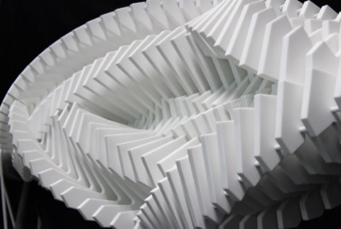
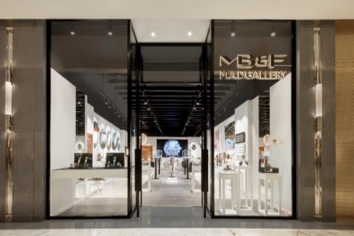
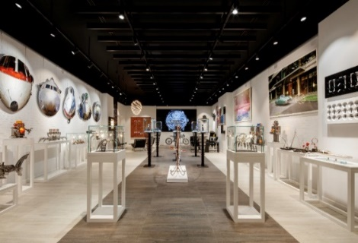
Dubai, UAE – 19th September 2018: The MB&F M.A.D.Gallery begins a new chapter with its expansion and relocation to Fashion Avenue, Dubai Mall, the world's most visited shopping and entertainment destination. The new gallery houses pieces from the universe of mechanical and kinetic art, including works by both Middle Eastern and international artists.
As part of the launch and for the premiere exhibition in the new space, the MB&F M.A.D.Gallery will be displaying geometrically engineered kinetic art by Dutch artist, Jennifer Townley. Townley’s art features shapes and forms with constantly evolving patterns that are continually being distorted and transformed. The exhibition entitled ‘Perpetual Transience II’ will introduce Townley’s artistic foray into kinetic sculptures.
Enchanted since childhood by geometric shapes and qualified with a degree in art from the Royal Academy of Fine Art in The Hague (2008), Townley's art derives from her fascination with science, with an emphasis on physics, engineering, and mathematics. Her interest led her to discover the works of fellow Dutchman, M. C. Escher, quite possibly the most famous graphic artist in the world. His “impossible” sketches and repetitive patterns inspired her to explore the geometric side of art. Captivated by how machines can convert relatively simple circular motions into quite complex nonlinear and chaotic patterns, Townley finds the robustness and apparent immortality of mechanical machines fascinating.
“While we’ve had incredible success in our previous location and have cultivated a strong following of art collectors, the new gallery in Dubai Mall will allow us to showcase our collection to a wider audience who are seeking a complete luxurious shopping experience in a convenient location. The M.A.D.Gallery was specifically designed to welcome artists like Jennifer Townley, who have made it their lifelong mission to create and embrace kinetic art. When I asked Jennifer why she only created one-of-a-kind art pieces, knowing how incredibly time consuming each piece is, she replied that her artistic freedom demanded it. For that, we salute her incredible integrity and talent,” said Maximilian Büsser, Founder and Creator of the MB&F M.A.D.Gallery.
Showcasing five unique limited-edition art pieces that generate repetitive movements and changing patterns designed to subtly interfere with the spectator's own patterns of thought, the exhibition will run from September 18th – January 18th, 2019 and include:
Asinas II
Limited edition of 6 pieces
Size: 130 x 110 x 50 cm
Material: Avonite, metal, electric motor and mechanical parts

Colorola
Limited edition of 1 piece
Size: 160 x 160 x 20 cm
Material: Necuron, steel, aluminium, mechanical parts, acrylic paint

Cubes L
Limited edition of 3 pieces
Size: 150 x 120 x 12 cm
Material: Aluminum, steel, wood, electric motor, mechanical parts

Cubes S
Limited edition of 6 pieces
Size: 60 x 55 x 10 cm
Material: Aluminum, steel, wood, electric motor, mechanical parts

161 Days
Limited edition of 1 piece
Size: 65 x 126 x 12 cm (WxHxD)
Material: Metal, wood, electric motor, mechanical parts, white cord, lead

-END-

About the M.A.D.Gallery:
The MB&F M.A.D.Gallery is a captivating universe of kinetic art where Horological Machines and Mechanical Art Devices reign supreme. The first M.A.D.Gallery opened in 2011 in Geneva on Rue Verdaine, a stone’s throw from MB&F’s offices and atelier in the heart of the city’s old town. A second location opened in 2014 in Taipei then a third in Dubai in 2016. Inside the galleries, you have the pleasure of discovering carefully-curated pieces – or, as we like to call them, Mechanical Art Devices – from around the world, each one making your heart beat that little bit faster. You exhale, only then to find the complete range of MB&F Horological Machines and Legacy Machines.
About MB&F:
Based around one very simple and fundamental ideal: to assemble dedicated collectives of talented horological artisans, artists and professionals – all friends – to design and craft each year a radical and original horological masterpiece. By nurturing teams of talented individuals, harnessing their passion and creativity and crediting each individual's essential role, MB&F uses their synergy to become much greater than the sum of its parts. MB&F is above all a human adventure... a human adventure with just one goal: to create incredible horological machines. 13 years of hyper-creativity; 14 remarkable calibres forming the base of the critically acclaimed Horological Machines and Legacy Machines for which MB&F has become renowned.
About Ahmed Seddiqi & Sons:
Curators of time since 1950, Ahmed Seddiqi & Sons is the Middle East’s most trusted destination for luxury watches and jewellery. Recognised today as a pioneer among the leading retailers in the region, the family owned-and-run company represents more than 60 luxury timepiece brands across 65 locations in the UAE.
An advocate of horology in the region’s retail landscape, Ahmed Seddiqi & Sons continues to create sustainable platforms for watchmaking and servicing, supporting watch enthusiasts and collectors in the region to increase their passion and understanding of the art of timekeeping.
Ahmed Seddiqi & Sons prides itself in offering unparalleled customer service across pre and post-sale dimensions. Led by the passion and credibility of the second, third and fourth generations of Seddiqi family members, the organisation delivers a dynamic commitment to preserving and enhancing the preservation, creation and innovation of watchmaking for decades to come.
www.seddiqi.com

M.A.D.Gallery Dubai
Address: Fashion Avenue Extension, The Dubai Mall, Dubai, U.A.E
Tel.: +971 4 388 2554
info@madgallery.ae

M.A.D.Gallery Geneva
Address: Rue Verdaine 11, 1204 Geneva, Switzerland
Tel.: +41 22 508 10 38
info@madgallery.ch

M.A.D.Gallery Taiwan
Address: 1F, No.2, Aly 232, Sec 1,
Dunhua S Rd, Da'an Dist,
Taipei 106, Taiwan
Tel.: +886 2 2775 2768
madgallery.taipei@swissp.com.tw

Follow M.A.D.Gallery Dubai
www.madgallery.ae
Facebook: MB&F MAD.Gallery Dubai
Instagram: mbfmadgallery.ae

