“Disintegrating X” by Swiss photographer Fabian Oefner
At the MB&F M.A.D.Gallery

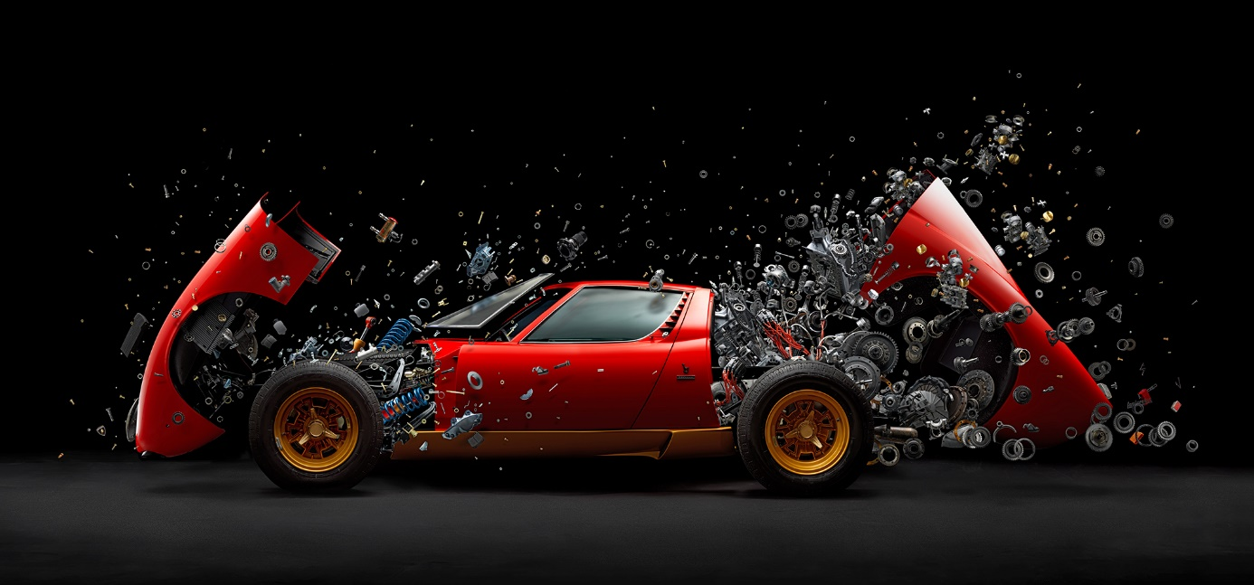

After “Disintegrating” and “Disintegrating II”, the M.A.D.Gallery is pleased to present “Disintegrating X”: a stunning photograph of an exploding Lamborghini Miura SV from 1972 by renowned Swiss photographer Fabian Oefner.

Living and working in New York, Fabian has carved out his reputation by fusing the fields of art and science, creating images appealing to heart and mind. Constantly exploring the boundaries between time, space and reality, he creates fictional moments and spaces, that look and feel absolutely real, yet aren't. Through this, Oefner dissects the different components of reality and gives us a clearer understanding of how we perceive and define it.

“Disintegrating X” in detail

For the first time, Fabian Oefner has created one of his highly acclaimed Disintegrating images with a real car. And not just any car: it’s the iconic Lamborghini Miura SV from 1972. The creation of the image took almost two years. During that time, Oefner and his team travelled to the workshops surrounding the Lamborghini Factory in Sant’Agata/Italy to capture each piece of the car as it was being restored. The final image, consisting of more than 1’500 individual photographs shows a new level of hyper-reality, that is unprecedented in the artist’s previous work.

“It had always been my dream to create an art piece with a real car. One day, a friend said to me, “I have a Miura and I’m having it restored. Why don’t you take the opportunity to create one of your Disintegrating images?” And of course he didn’t have to ask me twice to work on one of my favourite cars, to get to touch every single screw and piece of that legend, and put them into a final composition... that’s a dream come true!” says Fabian Oefner interviewed by the Lamborghini magazine.

He added: “It took two years and thousands of photographs to realize this work, from the first time the idea came to me to the final printed image. I depended on the restoration times of the workshop and the challenge was to always keep in mind the vision that I had at the beginning.”

During the same interview, when questioned about the big leap between the scale models and the real Miura, Fabian replied: “That’s quite different, yes. I worked on the scale models in my studio, which is very quiet, and creating was almost a soothing process. With the real car it got a lot more complicated: I was in the workshop where you’d have constant noise. Beside me, I had people working – and that was the most beautiful experience of this whole endeavor! – whom I was just asking, “Can I please have
a little corner?” Also, keep in mind I did this in July, so it was 44°C in the workshop, I was sweating, and it smelled like gasoline in the air. It’s way more tangible when you do it with the real thing. Now, when I look at the photograph, all the smells and the ambiance of the workshop come back.”

He finally described his feeling towards the Miura after spending a lot of time with the car: “When I started working with this car, I was seeing it “just” as the icon we all know, a Lamborghini Miura. But as the days went by, it became more and more special, and at the end of the process I knew every single detail of it. To me, it’s not just a Miura anymore, it’s become a bit like a person. Now it rolls on the road, finished and fully restored, and every time I see it I’m like, “Oh, I know you!”

The image is available in two sizes:
- 150x70cm limited to 18 prints + 2 artist editions
- 230x110cm limited to 8 prints + 2 artist editions

Maximilian Büsser, M.A.D.Gallery Founder and Curator said: “Fabian Oefner’s works are perfect examples of how mechanical art can be powerfully beautiful. Seeing objects we are so familiar with broken down into thousands of pieces, challenges the viewer’s perception of these items. ‘Disintegrating X’ truly encapsulates M.A.D.Gallery’s concept of celebrating the art of mechanics.”

Profile of Fabian Oefner

Now living and working in New York, Fabian Oefner was born in Switzerland in 1984. Coming from a family with an artistic background, he attended art school and gained a degree in product design.

Inspired by science, Oefner’s approach to art is highly methodical and at the same time playful for unexpected moments to happen. He creates carefully orchestrated works that are planned down to the last detail, as well as pieces that use a loose framework for art to happen.

“I create hyperrealistic objects and photographs, that challenge our idea of space, time and reality,” says the artist.

“Time and Space, which create the state we call reality, are evolving ideas that change progressively with our level of knowledge. They are only concepts helping us to orient ourselves in the world. At the current level, we believe that time is relative, that objects can be in multiple places at once and that space is an evolving, ever-changing state, defined by mass. We find it very easy to define if something is real or not, yet we struggle to explain why something is real. That’s what I am ultimately exploring with my art. I create fictional moments and spaces, that look and feel absolutely real, yet are fictional. In my art, I dissect the different components of reality to give us a better understanding of how we define reality,” he adds.

Fabian demonstrated his ideas and artwork during a TED Talk, as part of the non-profit’s initiative devoted to ideas worth spreading. His reputation has been growing steadily for the past seven years.

M.A.D.Gallery Geneva

Address: Rue Verdaine 11, 1204 Geneva, Switzerland
Contact: info@madgallery.ch
Tel.: +41 22 508 10 38
Website: www.madgallery.net
Shop at: http://shop.madgallery.ch

Follow us on Twitter, Instagram and Facebook @MBFMADGALLERY

