French artist Antoine Dufilho Designs a Fleet of Seductive Automobiles for “Sequential”, the Latest M.A.D.Gallery Exhibition

Sequential is an avant-garde exhibit of eight automotive works by the talented French sculptor Antoine Dufilho. In this collection, Dufilho merges his passion for cars with principles from his studies in medicine and architecture, creating modern sculptures accentuating the classic curves of coveted automobiles.

As avid car aficionados at the MB&F M.A.D.Gallery, we invite fellow enthusiasts to take a spin through the Sequential exhibit to discover the allure of this intricate automotive art.

Sequential
Dufilho selects the crème de la crème of icon models when it comes to cars for the Sequential exhibit. The collection includes an enviable line-up of eight famed automobiles, from a Ferrari 250 GTO and Bugatti Atlantic to a Mercedes W196 Streamliner, scaled-down and transformed into impressive artistic renditions.

The Bugatti Type 57S Atlantic and Aston Martin DB5 demonstrate the expertise of Dufilho: each sculpture decomposes the sleek lines and shapes of each vehicle into successive layers materializing into a modern automotive framework and revealing the contour of the car. “This sequenced representation provides a kinetic effect as the observer views the piece from different perspectives causing the sensation of a static object in movement. The dynamic effect is accentuated by alternating symmetries and asymmetries proving the feel of acceleration or deceleration,” explains Dufilho.

Bugatti Type 57S Atlantic  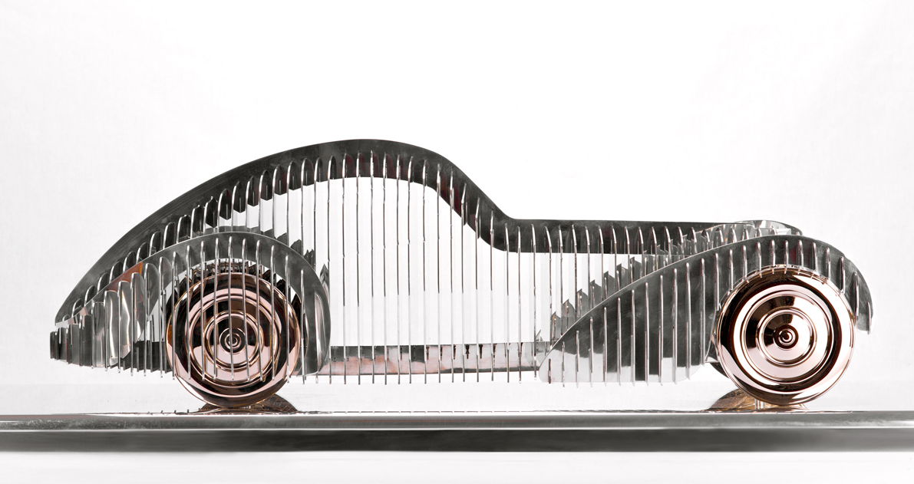 | Aston Martin DB5  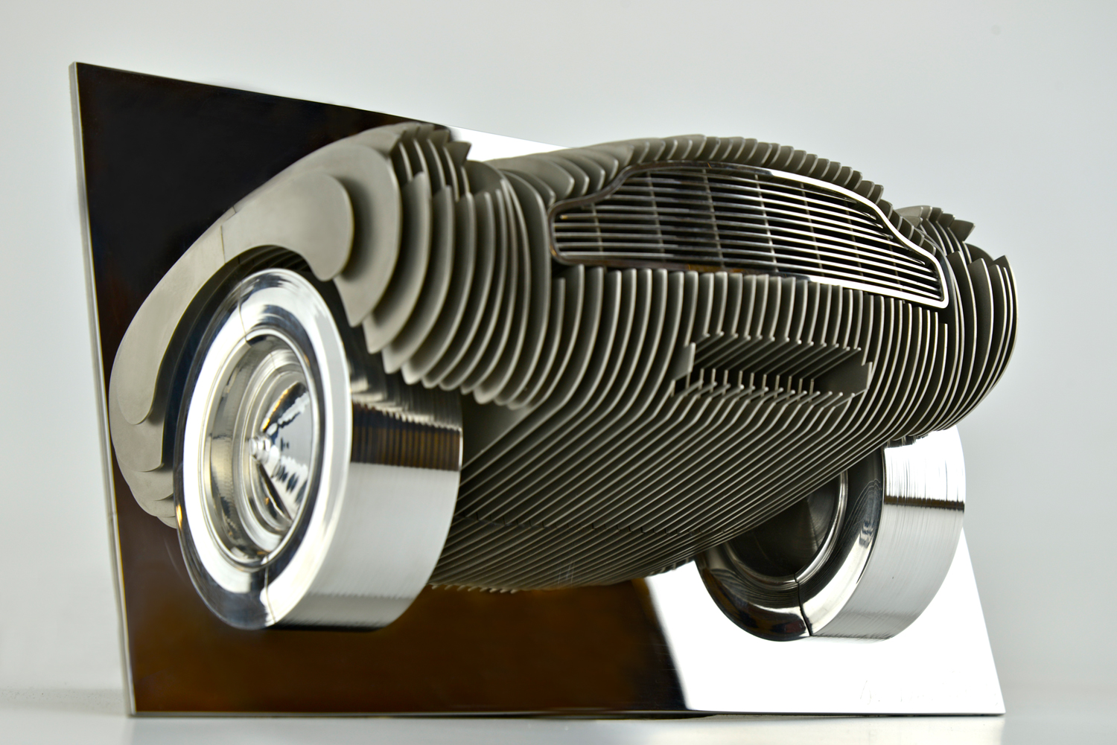

Perhaps one of the most important models in the history of Bugatti, sold from March 1934 to May 1940, is the Bugatti Type 57S Atlantic. Dufilho constructs a sexy silhouette of the iconic automobile with polished finished stainless steel plates and bronze wheels, parked on a polished aluminum base. The sculpture measures approximately 76 cm in length and 20 cm tall with a width of 33 cm and is limited to ten pieces in addition to two artist editions.

Another example of Dufilho’s artistic technique uses shaped stainless steel pieces strategically layered to present his rendition of the Aston Martin DB5, a car produced from 1963 to 1965 and often referred to as the ‘James Bond car’ that first appeared in Goldfinger. The front end of the Aston Martin in the wall is racing through the polished stainless steel mounting. Only eight pieces and four artist editions are available in this limited edition.

The Sequential collection also offers the Mercedes W196 Streamliner, Auto-Union-Avus, and Porsche 356. In a similar style and available as a wall mount is the customized Aston Martin DB4 GT Zagato.

Mercedes W196 Streamliner  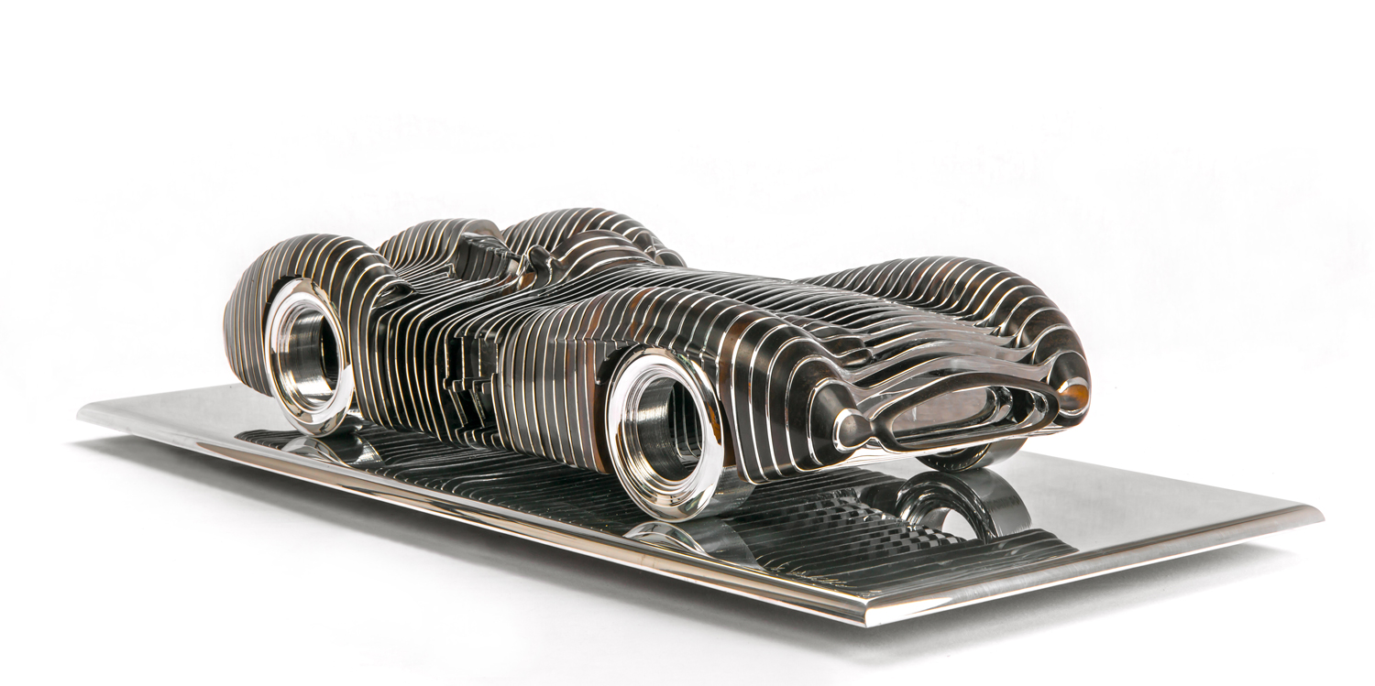 | Auto-Union-Avus  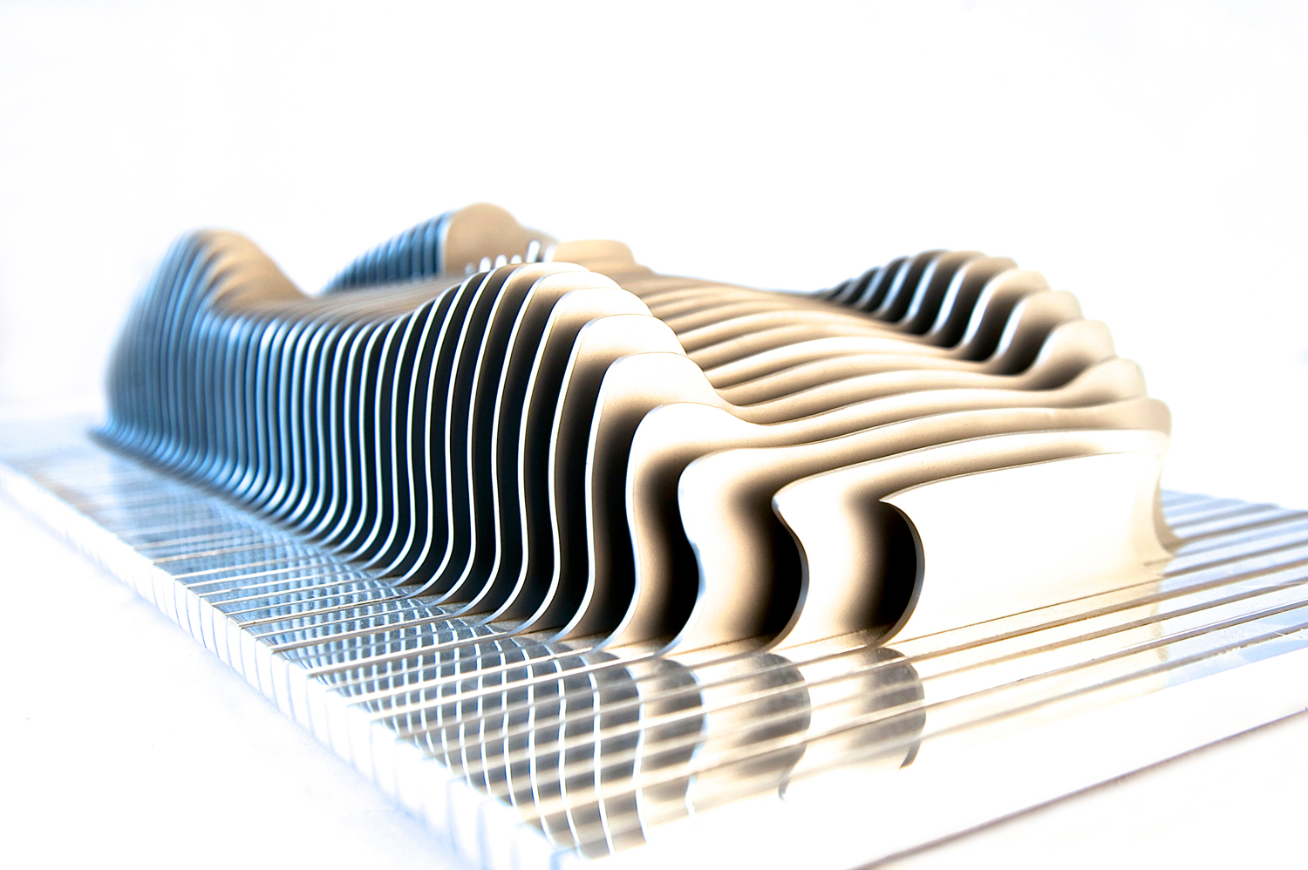
Porsche 356  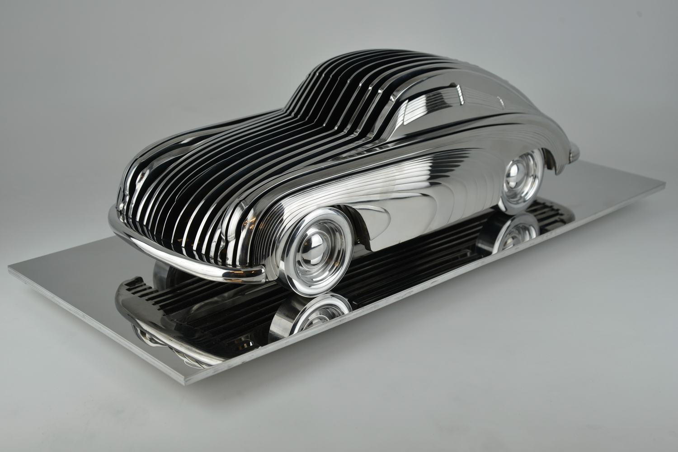 | Aston Martin DB4 GT Zagato  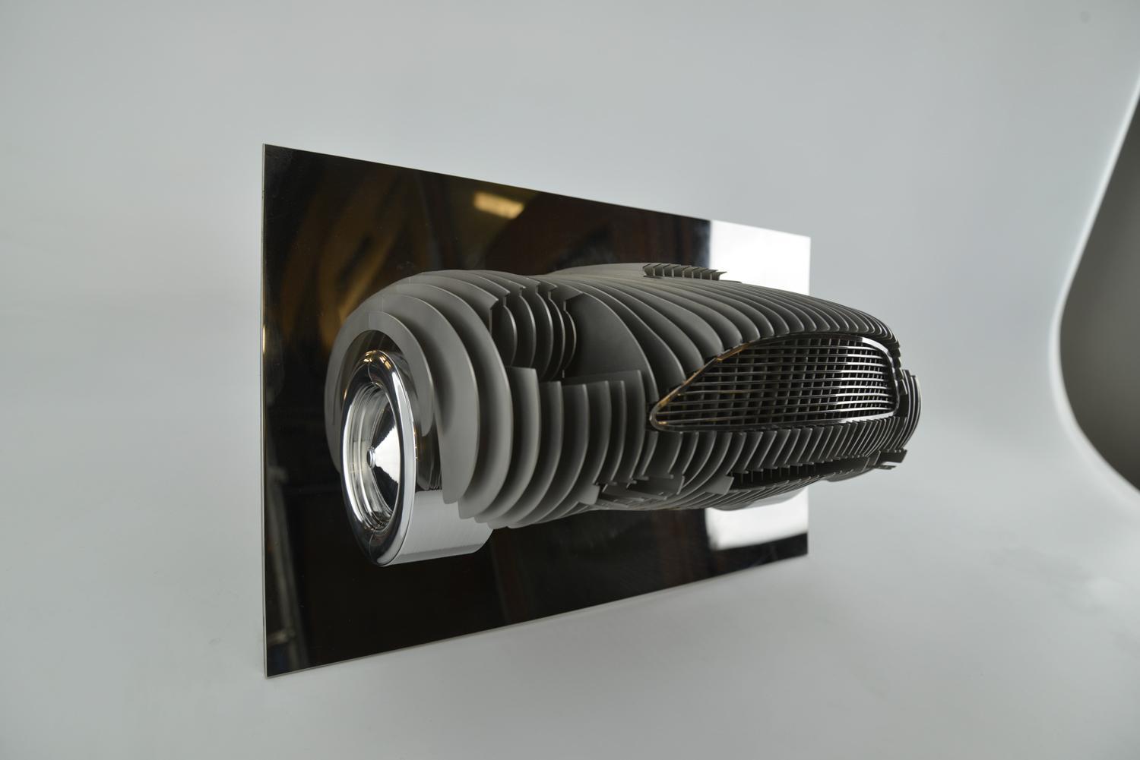

Dufilho expands his portfolio to include the legendary Ferrari 250 GTO model with a fuselage handcrafted in resin and finished with automotive paint enhancing the aerodynamic appeal of the car. The sleek lines and smooth, black surface of this work of art emphasizes Ferrari’s devotion to speed, even while parked on a 75 cm x 35 cm polished aluminum base. The Ferrari 250 GTO is available in a limited edition of eight pieces and four artist editions.

The creativity continues in a one-of-a-kind piece depicting the Jaguar E-Type, a superstar of the motoring world. In order to compose the sculpture Dufilho handcrafted 2,250 stainless steel rods, each measuring only 2 mm in diameter and colored to emphasize the exquisite aesthetics of the automobile. Once the rods are all strategically and meticulously placed, one by one on a rosewood base, viewers can discover a lightweight and airy representation of this renowned motorcar. Due to its unique construction, when rotating the base or walking past it feels as though the car is in motion. Standing 24 cm tall and 78.5 cm in length this miniaturize Jaguar is sure to look better in the home than the garage.

Ferrari 250 GTO  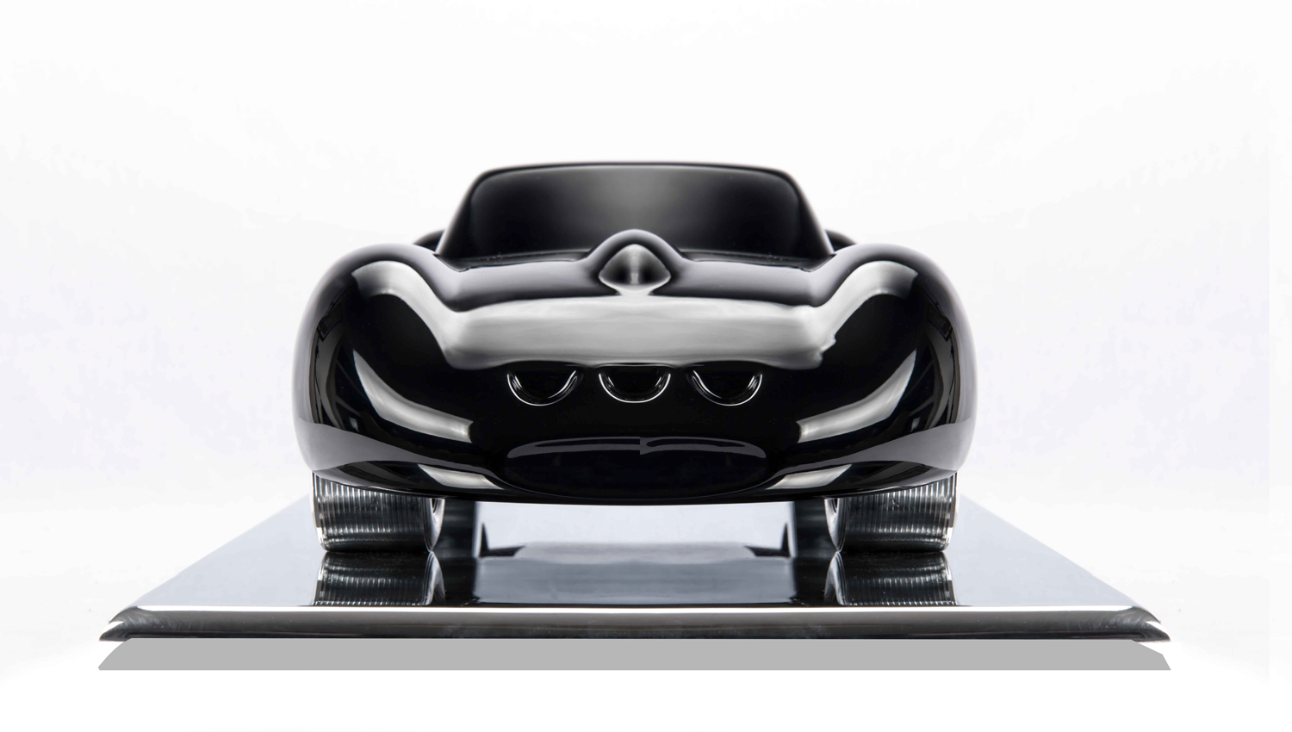 | Jaguar E-Type

Production Process
Dufilho’s educational background in architecture and medicine provides a conceptual foundation in which his innovative artworks are established. During his medical studies he was drawn to anatomy and the complex structures that are essentially hidden by skin while his architectural education taught him technical skills, introduced him to the history of art, and a new way of thinking. “Combining these two schools of thought has allowed me to develop a new structural approach, including the framework (skeleton) that can be hidden by a "skin" as enhancement, forming an aesthetic and dynamic meshing that strengthens the architectural intentions,” as Dufilho describes.

Working completely out of his workshop, constructed with shipping containers and situated in the Northern part of France in a town named Quesnoy-sur-Deule, Dufilho manually builds each masterpiece by hand. Over time the studio has grown into a playground for his artistic inventions and is equipped with all the necessary machinery from an assortment of belt sanders with a sanding cabin and industrial polisher to a painting booth, manual lathe, industrial hand milling machine and every type of welding machine imaginable.
Using local resources, Dufilho incorporates materials such as metals, wood, resin, and paint from vendors within a 30 km radius of his studio for his projects. The only work he subcontracts is the laser cutting of the metal plates and the remaining artisanship is completed by the talented hands of the artist himself. Dufilho shares, “The material that I use the most is metal because it is an element that allows me a freedom to add or subtract, unlike wood. Metal also has the advantage of being eternal unlike composite materials.” He continues, “Wood remains the most pleasant material to work with and brings interesting natural colors and designs while it is also still present in automobiles today.”

For Dufilho, each project brings its own challenges in workmanship, manufacturing time completely varying from one model to another. In the resin automobile sculptures, preservation of the dynamic characteristics of the models, such as the Ferrari 250 GTO, requires Dufilho’s personal touch in order to accentuate the aerodynamics of the car. The wooden iterations are the longest, taking two to three times longer than the others due to the laborious manual work. “Although the level of finish is not necessarily a determining factor in art, for me it is something that I place at a high importance,” proclaims the artist.

About the Artist
After studying architecture and medicine, Antoine Dufilho’s passion for art and automobiles led him to an enterprising new career in sculpture. He is surrounded by a close family filled with diverse and creative talents such as architecture, painting, and sculpting. His father is a surgeon and his great uncle is Jacques Dufilho, a famous French actor and producer. “During my childhood, the summers at my grandfather's house were largely devoted to making sculptures from clay harvested from his farm,” remembers Dufilho. It is not surprising Dufilho eventually found his knack in art.

In the same way his adoration for automobiles stems from family, “I come from a family of car lovers, starting with my grandfather and my great-uncle, an owner of a Bugatti Grand Prix, who passed on their love of automobiles to my father, a collector himself, he naturally transmitted the same passion to me,”

Dufilho created his first work, a rendition of the Bugatti Grand Prix, for his father’s birthday, in turn, opening many doors in the world of art and sculpture to him. Today his work can be found at the Petersen Automotive Museum in Los Angeles. Dufilho approaches it all in modesty, “My goal is not to work on a single subject, especially since I am still in the process of experimenting and discovering what can exist and be done.” His biggest challenge is in front of him, an ambitious project to construct a Bugatti Atlantic with aluminum plate to the exact size as the original.

